

Thakur College of Science and Commerce
College in Mumbai, India

IOT PROJECT

TOPIC :-SMART IRRIGATION AND MONITORING SYSTEM

NAME :- TRISHA UDAYA SHETTY
CLASS / DIVISION :- FYCS A
ROLL NO :- 1826

INDEX :-
Topic:- Pg.no
- Abstract 3
- Introduction 4
- Aim and Objective 5
- Problem Statement 5
- Methodology 6-24
- Block Diagram
- Working Principle
- Implementation Steps
- Circuit Diagram
- Hardware Components
- Software Components
- Flow Chart
- Algorithm
- Libraries And Modules
- FutureScope 25-26
- References 27
- Conclusion 28
- Output 28

- ABSTRACT:-

The main objective of this project is to develop an automation irrigation system using an Node MCU board with Internet being remotely controlled by any Android smart phone! So that agricultural lands are irrigate automatically without physical present of farmer. As technology is advancing so irrigations are also getting smarter! Modern irrigation pumps are gradually shifting from conventional switches to centralized control system# involving remote controlled switches. Presently conventional pump switches located in different parts of the agriculture land are makes it difficult for the user to go near them to operate and physically present on those areas. Even more it becomes more difficult for the elderly or physically handicapped people to do so remote controlled irrigation automation system provides a mostmodern solution with smart phones for those persons who want to do agriculture without physically present on that place . In order to achieve this a IOT (Internet of thing) module is interfaced to the Node MCU board at the receiver end while on the transmitter end of a *UI application on the cell phone sends ON+O commands to the receiver where loads are connected! -y touching the specified location on the *UI the loads can be turned ON+O,, remotely through this technology. The loads are operated by IOT board through delay Module Along with this we use a soil sensor. Which detect whether soil is dry or wet . When soil condition is dry soil sensor give command to IOT module to start the pump when soil becomes wet it gives command to stop the water pump. It works in accordance with the soil condition .This project is complete smart project for advance irrigation!

- INTRODUCTION:-
In this project, we'll explore an IoT-based irrigation system using the ESP32 board and Blynk app. It's a project based on the Internet of Things (IoT), the smart irrigation system offers numerous possibilities to automate the entire irrigation process. Here, we're creating a plot-based smart irrigation system using the ESP32 Controller, a soil moisture sensor, a water level sensor, a relay module and DHT22 Sensor. It will send data to the new Blynk application to monitor the land condition. The system includes a water pump that sprinkles water based on the land's conditions, considering factors like moisture, temperature, and humidity. This system is handy for farms and greenhouses. We will use Capacitive Soil Moisture Sensor to measure moisture content present in the soil. You can also use a resistive soil moisture sensor. and we use a water level sensor to measure water level inside the water tank. Similarly, to measure Air Temperature and Humidity, we prefer the DHT22 Humidity Temperature Sensor. Using a 5V Power relay we will control the Water Pump. When powered ON this system, the ESP32 board connects to the Blynk app using the internet and Blynk cloud. Then, the soil moisture values are displayed on the Blynk app interface. Whenever the sensor detects a low quantity (less than 50%) of moisture in the soil, the motor turns on automatically. Hence, will automatically irrigate the field. If the water sensor detects low
water level (less than 20%) inside the water tank in this case the motor will not turn on automatically. Once the soil becomes wet, the motor turns off. Also, with the button created in this Blynk app, we can turn the relay module ON and OFF manually in manual mode. You can monitor all this happening remotely via blynk App from any part of the world. A Smart Irrigation and Monitoring System using IoT can help optimize water usage and improve crop health by automating irrigation based on real-time environmental conditions. Below is a structured approach to developing this project. The system monitors soil moisture, temperature, humidity, and weather conditions to automate irrigation. It sends real-time data to a cloud platform or a mobile app, allowing users to remotely control and monitor the system. The scope of agriculture is reduced across all of India due to a rapid shift in climate and lesser rainfall. The most productive farming should be done without wasting any water. In the conventional technique, more water than what is required by the crop is used to irrigate the area. Modern irrigation systems like drip irrigation, sprinkle irrigation, etc. can reduce water waste. A sophisticated irrigation device's execution and design are widely accepted in a variety of settings, with the electric device offering the most dependable pricing performance. This paper proposes an IOT based smart irrigation tracking and management system using Arduino Uno microcontroller. The low-cost dependable gadget is designed to irrigate areas when there is a need for water and to provide data. This paper uses Node-Microcontroller ESP8266, DHT11 sensor and soil moisture sensor. The DHT11 sensor has a humidity measuring component and a NTC temperature component. The soil moisture sensor used for measuring the volumetric water content in the soil. The proposed smart irrigation system reduces wastage of water than the traditional process. The information is sent to the farmers by using cloud website called Blynk app. All the data is uploaded by Wi-Fi module inbuilt in microcontroller to Blynk app cloud database.

- AIM AND OBJECTIVE:-

There are two functional components in this paper. They are moisture sensor and motor / pump. Node MCU board is programmed using the Arduino IDE software. Humidity sensor is used to detect the soil moisture content. Motor / pump is used to supply water to plants. Soil moisture and temperature predetermined range is set particularly for specific plants requirement, and according to that system is being operated. Microcontroller (ATmega328) is the brain of the system. Both humidity and temperature sensor are connected to the controller' s input pin. Pump and servo motor coupled to the output pin. In case of soil moisture value is less than threshold system automatically triggers water pump on till sensor meets threshold and then sets off automatically. The overall activity is reported to the user using mobile application

- PROBLEM STATEMENT :-

Recent year gardening has become more popular. It is not just for food and for the business but as a hobby. Although just a hobby they need to monitor condition their garden in order to make the plant grow healthier and produce a high-quality product they need their plant grow in a good environment. Therefore, Irrigation system will be useful because it has a lot of control over how much water to supply and when to apply it but the irrigation system determines uniformity. The problem with this is how to ensure the condition is the good climatic condition that we want. Therefore, Irrigation system must be smart and full automation. A Smart Irrigation system will able to determine whether the condition is good or not by taking measurement of soil moisture, humid sensor, and temperature sensor. This measurement is then compared with recommended measurement in the application. A smart irrigation must also be automated to maintain the condition. The smart Irrigation system will automatically supply the water needed to t whenever there is anomaly measurement such as if the soil moistures is above average, a water will automatically turn off. That way the condition can be maintain and plant can grow into healthy plant.

- METHODOLOGY:-
The methodology outlines the step-by-step approach to designing, developing, and implementing the IoT-based smart irrigation system

1. Problem Identification
Traditional irrigation methods lead to water wastage and inefficient crop management.
Farmers lack real-time data to optimize water usage.
Manual irrigation increases labour costs and dependency.

2. System Design & Planning
Identify key requirements: automated irrigation, remote monitoring, and water conservation.
Select components: Microcontroller (ESP32/ESP8266/Arduino), sensors, actuators, and communication modules.
Define the control logic: Threshold-based irrigation using soil moisture and environmental conditions.
The system method includes the implementation of proto-type device work robotically and controlled thru the mobile application. For the prototype format drawing up the timeline and reading related works will be step one. After looking into benefits and downsides of previous studies in the subject of an automatic irrigation system, we can start implementing the layout and automation method for executable. The timeline of the project became set on the flowchart of the project. The steps can be in the following process chart:
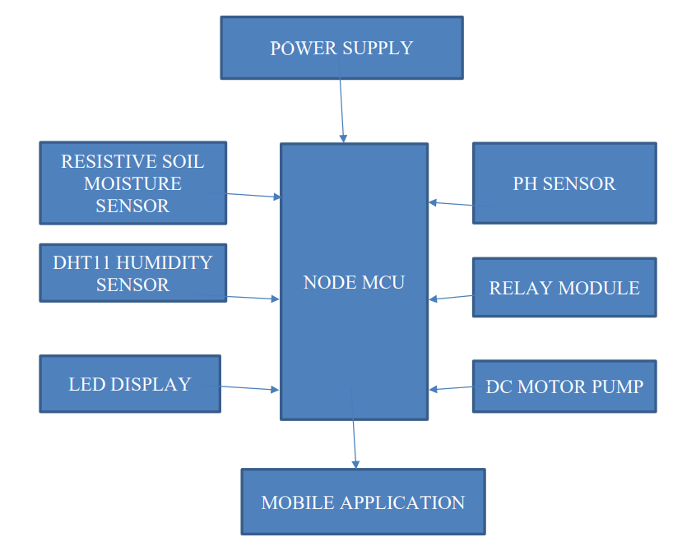

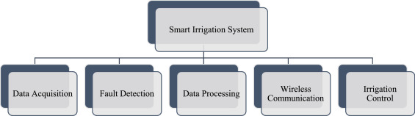
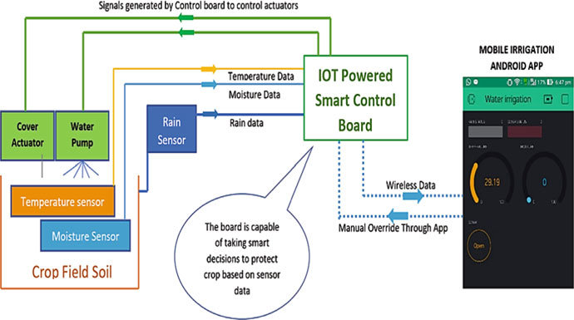
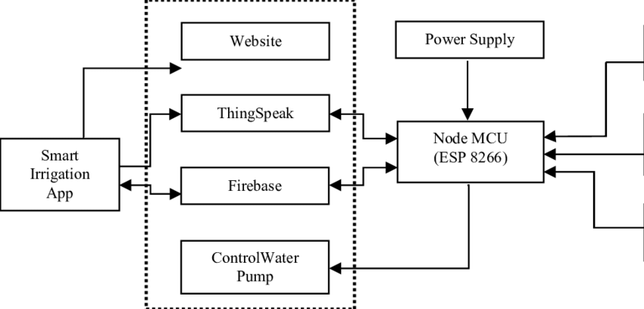
- BLOCK DIAGRAM:-

- Working Principle:-

1. Sensor Data Collection:
The soil moisture sensor checks soil dryness.
DHT11/22 records temperature and humidity. The water flow sensor monitors water usage.
2. Data Processing & Cloud Integration:
The microcontroller processes sensor data.
Data is sent to the cloud via Wi-Fi (ESP32/ESP8266) or GSM (SIM800L).
The user can view data and control the system remotely.

3. Automated Irrigation:
If the soil is dry, the relay activates the water pump.
When optimal moisture is reached, irrigation stops.

4. Alerts & Remote Control:
The system sends alerts via a mobile app or SMS.
Users can manually start/stop irrigation.

- Implementation Steps:-

1. Set up the microcontroller and connect sensors.
2. Write and upload Arduino code (using C++).
3. Integrate with an IoT platform (Blynk, Firebase, etc.).
4. Test automated irrigation based on sensor values.
5. Develop a mobile app (optional) for remote monitoring.
6. Optimize the system for power efficiency (e.g., using solar panels).

- CIRCUIT DIAGRAM:-

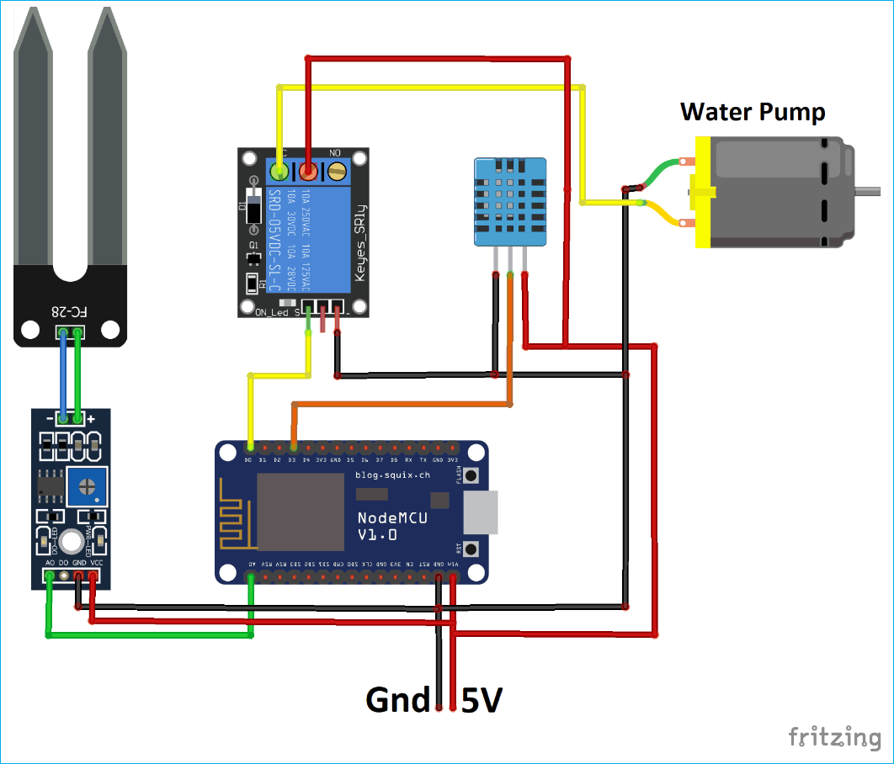
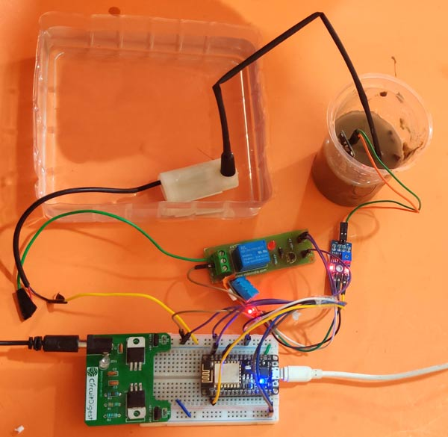

- HARDWARE COMPONENTS:-

- Microcontroller: ESP32/ESP8266 (Wi-Fi enabled) or Arduino with a GSM module
- Soil Moisture Sensor: Measures soil water content
- DHT11/DHT22 Sensor: Measures temperature and humidity
- Water Flow Sensor: Monitors water usage
- Relay Module: Controls the water pump
- Solenoid Valve: Automates water flow control
- Water Pump: Supplies water to plants
- LCD Display (Optional): Shows real-time sensor readings
- Solar Panel (Optional): For an eco-friendly power supply

1.Soil Moisture Sensor
There are two probes in the soil moisture sensor which is used to measure the volumetric content of water in soil. These two probes allow the current to pass through the soil and then it gets the moisture value present in the soil.
When there is water present in the soil, there will be less resistance and therefore soil will conduct electricity. As a result, the moisture level sensed by the sensor will be higher. Dry soil is a poor conductor of electricity. When there is less water in the soil, it will conduct less electricity and therefore resistance will be more. This is the reason moisture level will be lower.
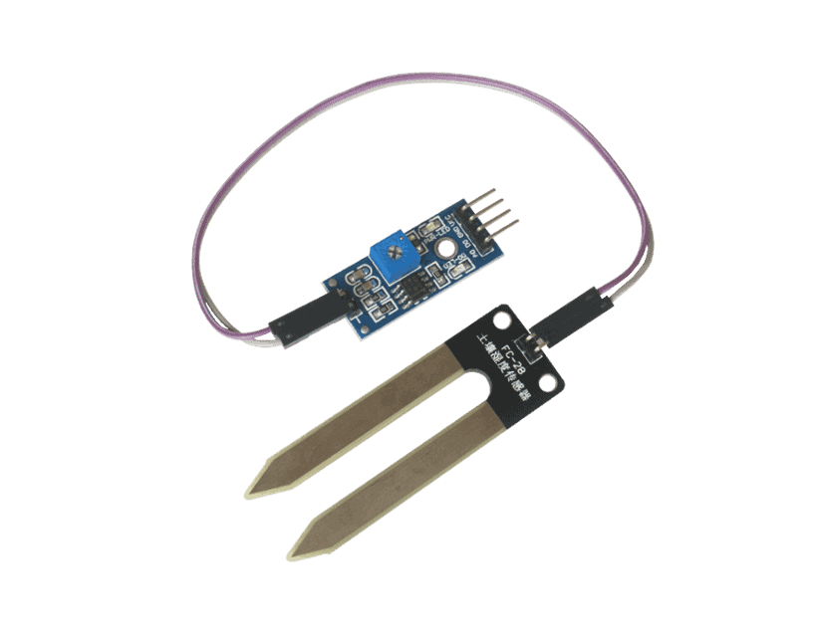

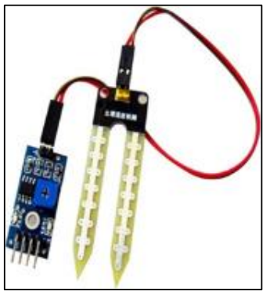

Technical Specifications:
- Input voltage – 3.3-5V
- Output voltage- 0- 4.2 V
- Input current- 35mA
- Output voltage- Analog/Digital

Pinouts of Soil Moisture Sensor:
- Vcc- Power supply
- A0- Analog output
- D0- Digital output

Soil moisture sensor works on the principle of open and closed circuit. When the soil is dried, no current will flow through it and it works like an open circuit. When soil is moist, the current will start flowing from one terminal to another, working as a closed circuit

2.TTL SIM800 GSM Module:
We have used SIM800 GSM module in our irrigation system project and interfaced with the Arduino to send and receive messages. A GSM module is basically a GSM modem. This device is connected with PCB to take different types of outputs from the board. In our project, we have interface the GSM module with Arduino and TTL output is taken. This quad-band GSM module works on frequencies ranging from GSM 850MHz, EGSM 900MHz, DCS 1800MHz and PCS 1900MHz. GSM modules are highly compatible with Arduino and microcontrollers. TTL SIM800 GSM Module is assembled in 24*24*3mm size to fit almost every device be it smartphone PDA etc.
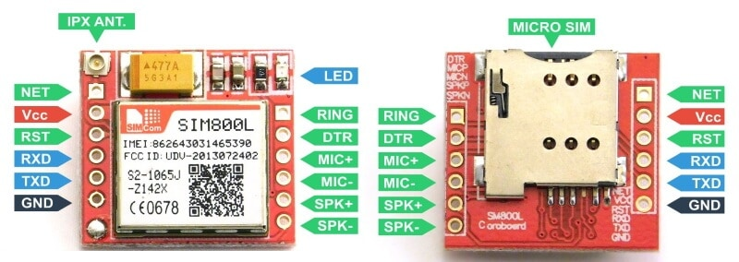

In Asia, most of the mobile phone operators operate in the 900 MHZ band. GSM modules are manufactured by connecting a single GSM modem to PCB. Then provision of RS232 output is provided. Make sure to double check the GSM power requirement in your project before choosing the suitable GSM module for your device. Also, always choose the TTL enabled output pins to interface it directly with Arduino without any inconvenience.

Technical Specifications:
- Quad band based
- Required voltage -9VDC-12 VDC
- Power supply- switching regulator based
- Power required- 1 MA
- Operating temperature- -40 TO + 85-degree Celsius
Features of GSM 800 Module:
- Coding scheme- CS-1, CS-2, CS-3, CS-4 Tx power
- It consumes low power
- Equipped with audio channels that include a microphone input and receiver output

3.DHT 11 sensor:-

The DHT-11 is a simple, very cheap digital sensor that measures temperature and humidity. It uses a capacitive humidity sensor and thermistor to measure the ambient air quality before sending a digital signal on the data pin (analog input pins are not needed). This sensor may be easily interfaced with any micro-controller, such as an Arduino, Raspberry Pi, or other device, to quickly measure temperature and humidity. For the DHT11 sensor, there are two options: a sensor and a module. This sensor can be identified from the module by its pull-up resistor and power-on LED. DHT 11 sensor has a thermistor to sense the surrounding air temperature in addition to a capacitive humidity sensor

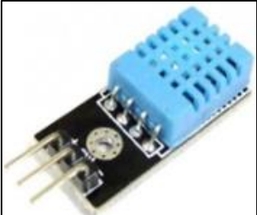

4.Arduino UNO

A well-known microcontroller board based on the ATmega328P chip is the Arduino Uno. It is a member of the Arduino family, which is known for its open-source hardware and software. It provides an easy-to-use platform for developing interactive electronic projects, featuring digital input/output pins, analog inputs, PWM outputs, and moreTheArduino IDE (Integrated Development Environment) makes programming the board easier by streamlining the authoring and uploading of code. An detachable dual-inline-package (DIP) ATmega328 AVR microcontroller, six analog inputs, a 16 MHz crystal oscillator, fourteen digital input/output pins (six of which can be used as PWM outputs), a USB port, a power jack, an ICSP header, and a reset button are all included in the most recent version, the Arduino Uno R3. All necessary components for microcontroller support are included, allowing for USB
connection to a computer, battery, or AC-to-DC converter powering. Unlike previous boards, the Uno does not use the FTDI USB-to-serial driver chip. For those new to embedded electronics, the Arduino Uno is a great choice because of its large support network.

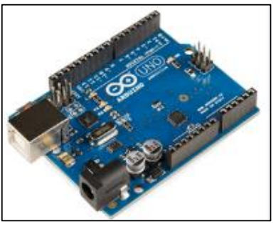

5.Relay:-

A relay is a switch operated electrically, allowing a low-power signal to command a circuit with high power. It comprises an electromagnet, armature, contacts, spring, and enclosure. When the electromagnet is energized by the control signal, the armature moves, opening and closing the circuit contacts. Different types of relays include electromechanical, solid state, reed, time-delay, and polarized variants. They are utilized in automotive systems, telecommunications, industrial automation, home appliances, and power systems. Relays offer a reliable means to control high-power devices safely and efficiently, playing a vital role in enabling remote control, automation, and circuit protection.

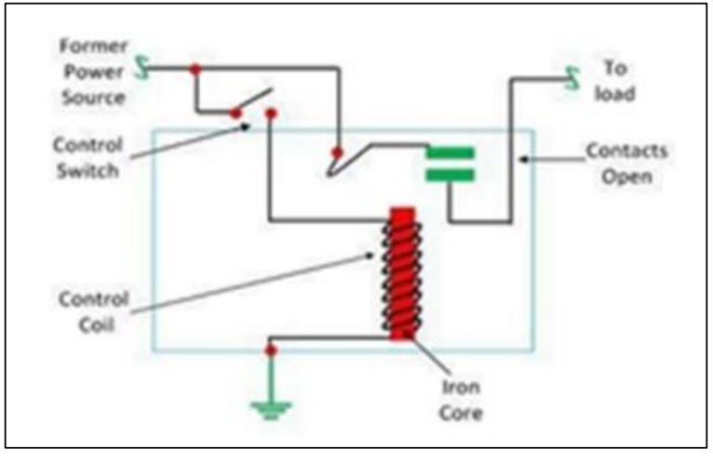

6.Water pump:-

A submersible pump is designed to operate underwater, wells, boreholes, or reservoirs to raise the water's surface through pumping. These pumps are often used to get water from underground sources, such as groundwater wells or storage tanks. They are characterized by hermetically sealed motor enclosures, allowing them to function efficiently and safely while fully submerged. Submersible pumps are commonly employed in residential, commercial, agricultural, and industrial settings for various purposes, including the availability of water, irrigation, drainage, and wastewater treatment.

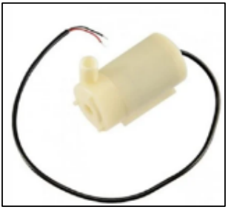

- Design and implementation:-
The Arduino board receives a signal from the detector when the soil begins to dry out, and it uses that signal to activate the pump. Once the required moisture content of the soil is reached, the Arduino turns off the pump. The soil moisture detector functions as a variable resistor, meaning its resistance changes based on the conductivity between its two probes. The conductivity of these probes changes with the moisture content of the soil when they are inserted. Resistance is high and conductivity is low in dry soil, while resistance is low and conductivity is high in humid soil. Therefore, the resistance of the sensor and soil moisture have an inverse relationship. This shift in resistance can be compared to the output voltage. The analog output voltage falls with increasing
soil moisture content and vice versa. Analog input for the Arduino is provided by the output voltage of the sensor. From 0% to 100%, the Arduino determines the soil's moisture content by converting this input into a digital value. The Arduino utilizes a transistor to initiate the pump using a relay when the moisture level falls below a preset threshold, like 10 or 20%. The earth gets wetter as the pump runs. The moisture content of the soil is continuously monitored by the Arduino. Upon reaching the targeted moisture level (such as 90 or 95%), the Arduino deactivates the relay, so stopping the pump. Repetition of this cycle guarantees that the plant receives water whenever the soil dries out.

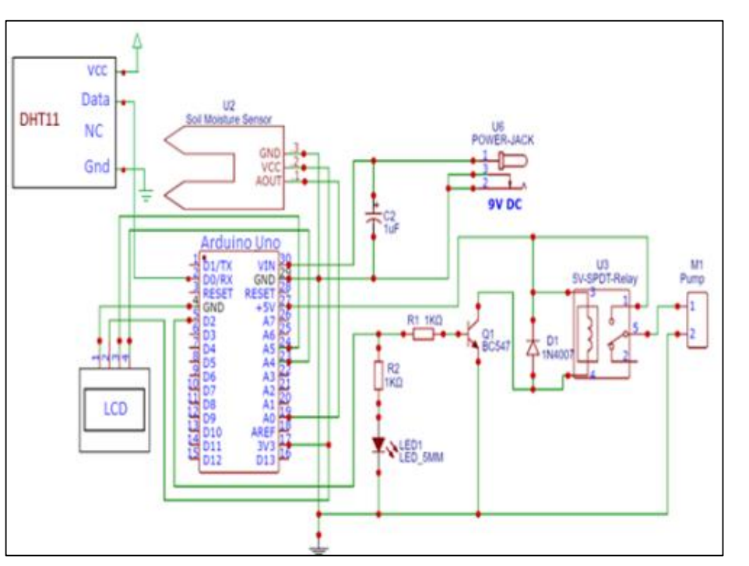
- SOFTWARE COMPONENTS:-

1.Arduino IDE Tool version 1.8.12
Arduino IDE tool (software) is an open source environment where we can write a code and upload it on to UNO board. It runs on windows Mac OS and Linux OS.

2. Python 2.7
Python is an interpreter, high-level and general-purpose programming language

The software program of the node mainly consists of five parts: data acquisition program, storage program, valve control program, data packet reception and transmission program, and power consumption management program. The flowchart of the node software design is shown in Figure 6. Initially, upon powering up, each module undergoes initialization, after which the positioning module is analyzed to determine the location of the node. The CPU then transitions into the STM32’s low-power sleep mode. It is awakened under two specific conditions: the first is when the LoRa module receives data and USART generates a receive idle interrupt; the second is when the timer triggers an overflow interrupt during the intermittent reading of the flow meter data after irrigation is started. The data acquisition program initiates upon receiving the polling frame from the gateway via the serial port, employing the Modbus-RTU protocol to interrogate the moisture content across various soil layers of soil sensors, each identified by unique slave addresses. Once parsed, the data are transmitted to the gateway as a string, adhering to a frame structure encompassing a header, footer, node address, soil moisture data, and geolocation data. The storage program leverages the FatFs file management system to generate CSV files on the SD card, archiving details such as date, time, moisture content across different soil strata, geolocation coordinates, and irrigated water volume for subsequent review on other devices. The valve control program is designed with two modes: manual control and automatic control. Under automatic control, the program initiates irrigation after parsing the irrigation command transmitted by the gateway. Utilizing the overflow interrupt flag of a defined timer command transmitted by the gateway. Utilizing the overflow interrupt flag of a defined timer, the program reads the flow meter’s cumulative flow every 30 s and compares it against the designated irrigation volume. Once the target irrigation volume is achieved, the valve and timer are deactivated, and subsequently, data are uploaded, including post-irrigation soil moisture levels and the volume of water irrigated at the node.
In summary, the nodes are primarily responsible for collecting soil moisture information and field location information; after processing and local storage, the data are reported to the higher-level gateway. They can also receive commands from the gateway to control the opening and closing of water valves, execute irrigation operations, and after the irrigation is
completed, upload the soil moisture content and irrigation volume after irrigation to the gateway.

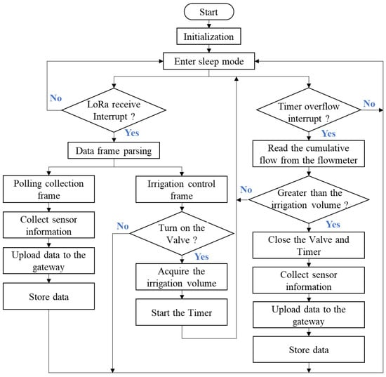
- FLOW CHART:-

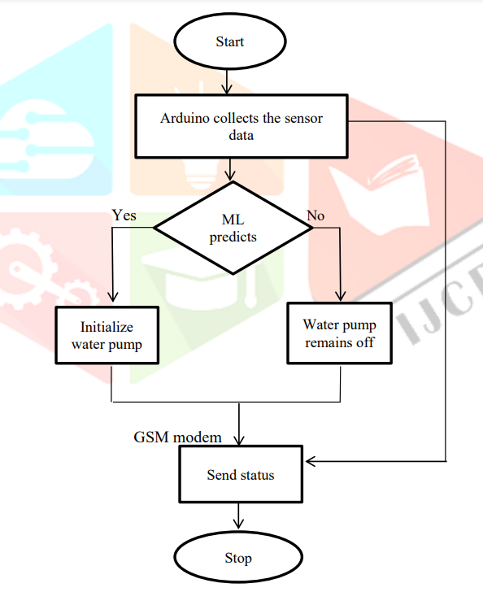

- SNAPSHOT OF SMS SENT TO USER:-

• Senario1: Soil moisture is LOW but water level is empty hence MOTOR will remain OFF
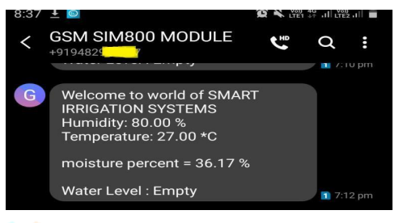

- Senario2: Soil Moisture is LOW and hence MOTOR is ON
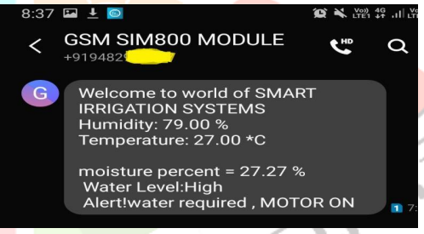

- Senario3: Soil Moisture is HIGH hence MOTOR is OFF

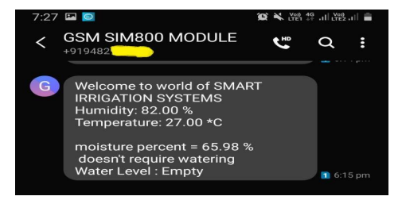

- ALGORITHM:-

1. Start
2. Initialize Sensors
Soil Moisture Sensor
Temperature & Humidity Sensor
Water Level Sensor
pH Sensor (if required)
3. Read Sensor Data
Read soil moisture level
Read temperature and humidity
Read water level in the reservoir
4. Check Soil Moisture Condition
If moisture is below threshold, turn ON the water pump
If moisture is above threshold, turn OFF the water pump
5. Check Weather Conditions (if integrated with weather API)
If rain is predicted, delay irrigation
6. Monitor Water Level
If the water level in the tank is low, alert the user
7. Send Data to User
Display real-time data on IoT/cloud platform or mobile app
Notify the user if manual intervention is required
8. Loop Back to Step 3 for continuous monitoring
9. End

- LIBRARIES AND MODULES:-

The libraries and modules required depend on the hardware and platform used. Below is a categorized list of libraries for different functionalities:

1. Sensor Data Acquisition
These libraries help in reading data from sensors like soil moisture, temperature, humidity, and water level.
- For Arduino (C++):
- DHT.h – For DHT11/DHT22 Temperature & Humidity Sensor
- Wire.h – For I2C communication with sensors
- SPI.h – For SPI communication
- OneWire.h – For DS18B20 temperature sensor
- Adafruit_Sensor.h – Generic sensor handling
- DFRobot_SoilMoistureSensor.h – For soil moisture sensor

- For Raspberry Pi (Python):
- RPi.GPIO – To control GPIO pins
- Adafruit_DHT – For DHT11/DHT22 sensor
- smbus – For I2C-based sensors
- gpiozero – For controlling pumps and actuators
- time – For time-based operations

2. IoT Communication & Cloud Integration
These libraries help send data to cloud platforms or mobile apps.
- For MQTT Communication:
paho-mqtt – MQTT protocol for IoT communication
- For HTTP Communication REST APIs):
requests – To send data to a web server
urllib – For handling URLs
- For Firebase Integration:
firebase-adFomin – To send data to Google Firebase
- For ThingSpeak (IoT Data Logging):
urllib3 – To send sensor data to ThingSpeak

3. Machine Learning & Data Processing (Optional, for Advanced Applications)
If you want to implement predictive analytics in your system
- numpy – For numerical calculations
- pandas – For handling sensor data
- scikit-learn – For machine learning models
- tensorflow – For deep learning models

4. GUI & Web Dashboard (For Monitoring Data)
To visualize the data in real-time:

For Python Web Development:
- Flask – Lightweight web server for a dashboard
- Dash – Data visualization
- matplotlib – To plot sensor data
- Plotly – Interactive charts
- For Arduino-Based Web Interfaces:
- ESP8266WiFi.h – WiFi connectivity for ESP8266
- WiFi.h – WiFi module for ESP32

5. Motor & Relay Control (For Water Pump Automation)
For Arduino & ESP:
Servo.h – To control servo motors
Relay.h – To operate a relay module
For Raspberry Pi (Python):
RPi.GPIO – To control relay and motor pumps
gpiozero – To handle GPIO-based automation

- Example Code for a Smart Irrigation System (Raspberry Pi - Python)

import RPi.GPIO as GPIO
import Adafruit_DHT
import time
import requests

# GPIO pin setup
SOIL_MOISTURE_PIN = 17
RELAY_PIN = 18
DHT_SENSOR = Adafruit_DHT.DHT11
DHT_PIN = 4

GPIO.setmode(GPIO.BCM)
GPIO.setup(SOIL_MOISTURE_PIN, GPIO.IN)
GPIO.setup(RELAY_PIN, GPIO.OUT)

while True:
humidity, temperature = Adafruit_DHT.read(DHT_SENSOR, DHT_PIN)
soil_moisture = GPIO.input(SOIL_MOISTURE_PIN)

if soil_moisture == 0: # Dry soil
GPIO.output(RELAY_PIN, GPIO.HIGH) # Turn on water pump
else:
GPIO.output(RELAY_PIN, GPIO.LOW) # Turn off water pump

# Send data to cloud (Example: Thingspeak)
api_url = "https://api.thingspeak.com/update?api_key=YOUR_API_KEY"
data = {'field1': temperature, 'field2': humidity, 'field3': soil_moisture}
requests.get(api_url, params=data)

time.sleep(10) # Delay before next reading

FUTURESCOPE:-

Smart irrigation systems are evolving rapidly with advancements in IoT, AI, and automation. Here are some key future trends and developments:

1. AI and Machine Learning for Predictive Irrigation
AI models can analyze weather forecasts, soil conditions, and crop types to predict irrigation needs.
Machine learning algorithms can optimize water usage by learning from past patterns.
Automated decision-making for irrigation scheduling based on real-time data.

2. IoT and Cloud-Based Smart Farming
Real-time Monitoring: Farmers can monitor soil moisture, temperature, and water levels remotely.
Integration with Cloud Platforms: Data can be stored and analyzed on cloud platforms like AWS, Google Cloud, and Azure.
Mobile App Control: Farmers can receive alerts and control irrigation systems via mobile apps.

3. Integration with Weather Forecasting Systems
AI-driven weather prediction can help farmers prepare for rainfall, droughts, or extreme weather conditions.
Systems can automatically adjust irrigation schedules based on upcoming weather conditions.

4. Automated and Drone-Based Irrigation
Drones with Thermal Cameras: Can detect dry areas in fields and target irrigation more precisely.
Automated Sprinklers and Drip Irrigation: Can be controlled remotely or set to work autonomously.

5. Smart Water Management and Conservation
IoT-Enabled Water Tanks: Sensors monitor water levels and prevent wastage.
Recycling and Rainwater Harvesting: Smart systems can integrate with rainwater collection for sustainable irrigation.
Government and Environmental Compliance: Advanced water conservation techniques to align with sustainability goals.

6. Blockchain for Agriculture Data Security
Farmers can track and verify crop irrigation records.
Secure transactions for water usage billing and resource management.

7. Solar-Powered Smart Irrigation Systems
Integration with solar panels to reduce energy costs and promote eco-friendly farming.
AI-driven energy management to optimize pump operations based on sunlight availability.

8. Smart Fertilization (Fertigation) Systems
Automated nutrient delivery based on soil analysis.
IoT-enabled sensors to detect deficiencies in soil nutrients and adjust fertilizer levels accordingly.

9. 5G and Edge Computing in Agriculture
Faster data transmission and real-time decision-making.
Reduced latency for remote monitoring and automated irrigation control.

10. Government and Industry Adoption
Increased funding and adoption of smart irrigation in precision agriculture.
Policies promoting smart water management and sustainable farming.

- REFERENCES:-

LINKS :-nevonprojects.com
circuitdigest.com
1. Ganesh Babu Loganathan, Dr.E.Mohan, R.Siva Kumar “ Iot Based
Water and Soil Quality Monitoring System”, International Journal of
Mechanical Engineering and Technology (IJMET) Volume 10, Issue
02, February 2019.
2. Samarth Mehta, Namrata Saraff,Sahil Sawant Sanjay, Shaily Pandey,
“Automated Agricultural Monitoring and Controlling System Using
HC05 BT Module”, International Research Journal of Engineering and
Technology (IRJET), Volume: 05 Issue: 05, May-2018.
3. Sharmila Nath, Jayanta kumar Nath, Prof. Kanak Chandra Sarma “IoT
Based System for Continuous Measurement and Monitoring of
Temperature, Soil Moisture and Relative Humidity”, International
Journal of Electrical Engineering & Technology (IJEET) Volume 9,
Issue 3, May-June 2018.
4. Dr. D. P. Patil, Angad H. Singh, Suraj R. Jadhav, Shashank R.
Thombare “IoT Based Agriculture and Transportation Surveillance”,
Global Research and Development Journal for Engineering, Volume 3,
Issue 6, May 2018.
5. Bobby Singla, Satish Mishra, Abhishek Singh, Shashank Yadav “A
study on smart irrigation system using IoT”, International Journal of
Advance Research, Ideas and Innovations in Technology, Volume 5,
Issue

- CONCLUSION:-

The Smart Irrigation and Monitoring System is a revolutionary approach to modern agriculture, leveraging IoT, AI, and automation to optimize water usage, enhance crop health, and improve efficiency. By integrating sensors, cloud computing, and real-time monitoring, farmers can make data-driven decisions, reduce water wastage, and increase agricultural productivity.

This system not only ensures sustainable water management but also helps in adapting to climate change, reducing manual labor, and lowering operational costs. Future advancements in machine learning, 5G, and smart fertigation will further enhance precision farming, making agriculture more efficient, eco-friendly, and profitable.

The widespread adoption of smart irrigation technology can play a significant role in global food security and water conservation, making it an essential innovation for the future of smart farming.
- OUTPUT:-
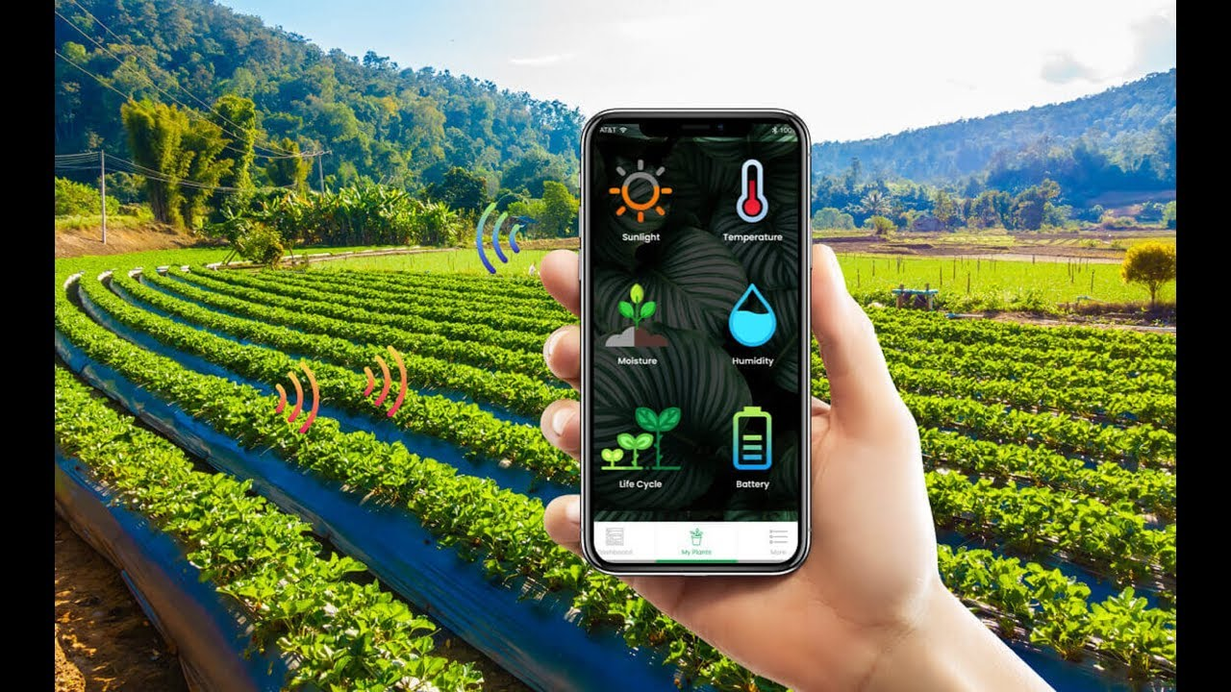

- Thank You

